***Lab 06***

***Functions, scope of variables and argument passing***

**Pre-Lab Reading 1:**

**Scope of Variables:**

A scope is a region of a program. Variable Scope is a region in a program where a variable is declared and used. So, we can have three types of scopes depending on the region where these are declared and used:

• **Local variables** are defined inside a function or a block

• **Global variables** are outside all functions

• **Formal parameters** are defined in function parameters

**In-Lab Task 01:**

Given the C program in the following code listing, complete the function sum_of_prod() that takes 4 inputs (floating point numbers) and returns the their sum of products. Observe the outputs generated by the program and explain what is happening with the Global variables and the Formal Parameters.

**Program code:**

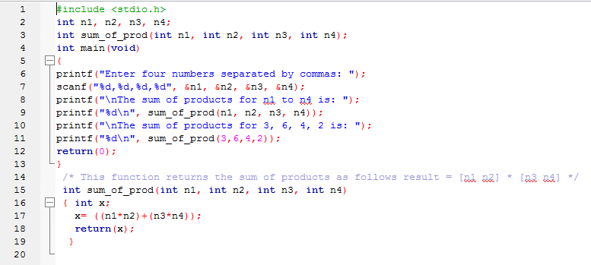

**Output:**

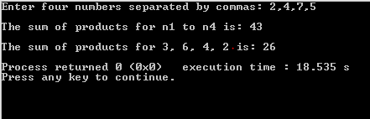

**In-Lab Task 02:**

Write a C program that inputs the value of n from the user and calculates the value of the function

y = f1[n] + f2[n]where

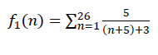 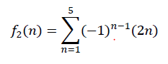

The program should print the value of y on the console screen as well. Write separate functions to compute f1[n] and f2[n].

**Program code:**

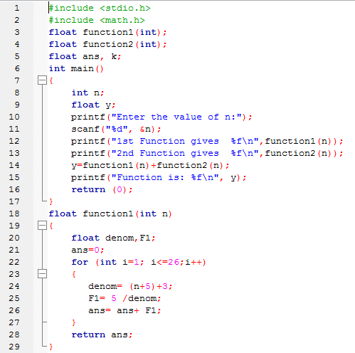

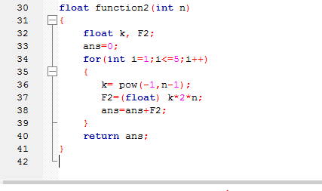

Output:

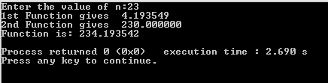

**Post Lab Task:**

Write a similar program as In lab task 01 but for the following functions f1[n] and f2[n].

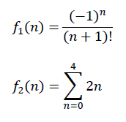

**Program code:**

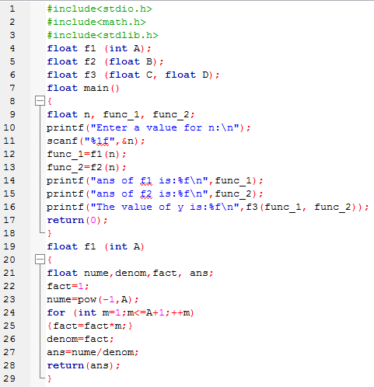

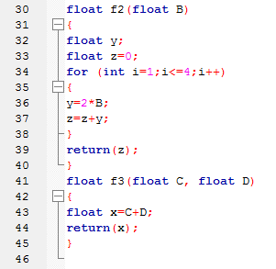

**Output:**

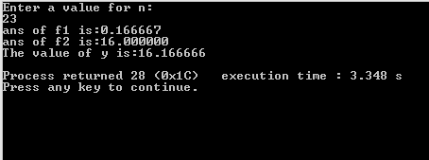

**Critical Analysis:**

In this lab, we understand the concept of scope of variables when working with custom functions. We learn the difference between global and local variable. Formal parameters are used instead of local variable in function or program.